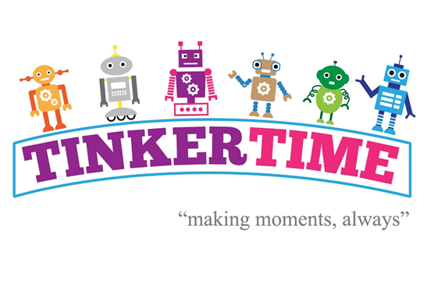

Dear Tinkerbots in ________________
We would like to thank you for amazing effort and creativity in making your version of your house out of bits and pieces!
We would like to issue another challenge…
We would like to explore the possibilities of extending our community in Space. We want you to come up with some creative, innovative ideas for a place in Space.
What would it look like?
How would you live in it?
Would it be on another planet or just float in space?
We are giving you a small package to take home. Your family can help you design and create a place in Space. There are instructions. When you have finished, please return your finished place in Space to the Mayor of MACCCOT.
We know that you are very creative and will have some wonderful ideas. We can’t wait to see them!

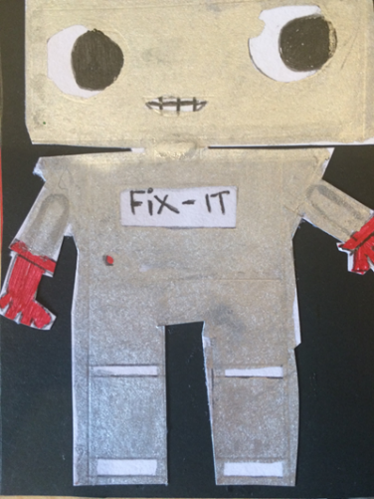

The Tinkerbot Elves

