Tinkertime

Knights of Old, Heroes to the Rescue!

Term 4 2016

Overview
Tinkertime is an opportunity for Stage 2 students to explore Design Thinking in relation to STEM learning. It has a project based focus, where students are given a range of challenges that they apply creativity and problem solving to explore new concepts and develop skills.

Resources
- Visual Story Map of the Three Little Pigs

Week | Outcome/Content Marker | Learning Intention | Teaching/Learning Tasks | Assessment ( for/as/of learning)
2 -3 | EN2-10C  A student thinks imaginatively, creatively and interpretively about information, ideas and texts when responding to and composing texts.  ST2-5WT  A student applies a design process and uses a range of tools, equipment, materials and techniques to produce solutions that address specific design criteria  MA2-1WM  A student uses appropriate terminology to describe, and symbols to represent, mathematical ideas  MA2-17MG  A student uses simple maps and grids to represent position and follow routes, including using compass directions | Students will create a story maze of a fairy tale. They will use the Ozobots to show the journey of the story. | Introduction:  Revise the previous week’s lesson where students solved a maze, by creating a path for the Ozobots to follow. Brainstorm the things that they learned from that process.  Discuss with the students that they will be retelling a Fairy tale using the Ozobot to help them. The Ozobot will be the hero! You are going to take your Ozobot on an Adventure!  Watch the following videos to get some ideas:  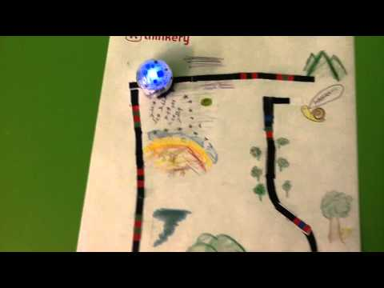  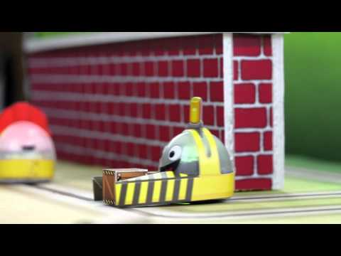  The Hero’s Journey  Have a range of books, pictures etc of fairytales that students can choose and refer to. Have students discuss and then choose a resource and a fairytale that they can use as the basis of their Ozobot Adventure.  Give each group a story map that they can write the key details of their adventure. Model how to fill the story map in and then students collaborate on their story map together.  Once students have created their story map, they need to develop a visual story maze that is a visual form of their map. Refer to the resources for more ideas but an example is the following picture of the three little pigs. It shows the path that the pigs must take to get to each of the houses. What could the Ozobot do when it comes to the big bad wolf? What would you code? What could the Ozobot do when it reached each of the houses?  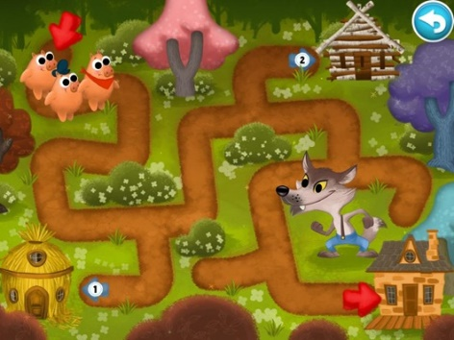  Give students access to A3 pieces of paper to design their Fairy Tale Story Journey. Students must think about the following:  - The Ozobot is the hero of the story. What will it do on its journey? Who will it meet? What path will it take to be safe?  - The path must take the Ozobot on a journey of the fairy tale.  - They must use code on their journey to tell the Ozobot what to do at each stage of the journey.  Students create their design and then test their designs. What is working? What needs improving?  Conclusion:  Students share their Story Journey’s with the rest of the group. They could show what codes they have used and what the Ozobot will do on its Journey. |  | Assessment for learning:  Assessment as learning:  Observation of students  Work samples  Assessment of learning

